**EMBARGOED UNTIL SEPTEMBER 18 AT 22.00**

THE SIMPSONS AND SPINAL TAP STAR
HARRY SHEARER
Releases Eighth Song in Donald Trump Series

ACQUITTAL
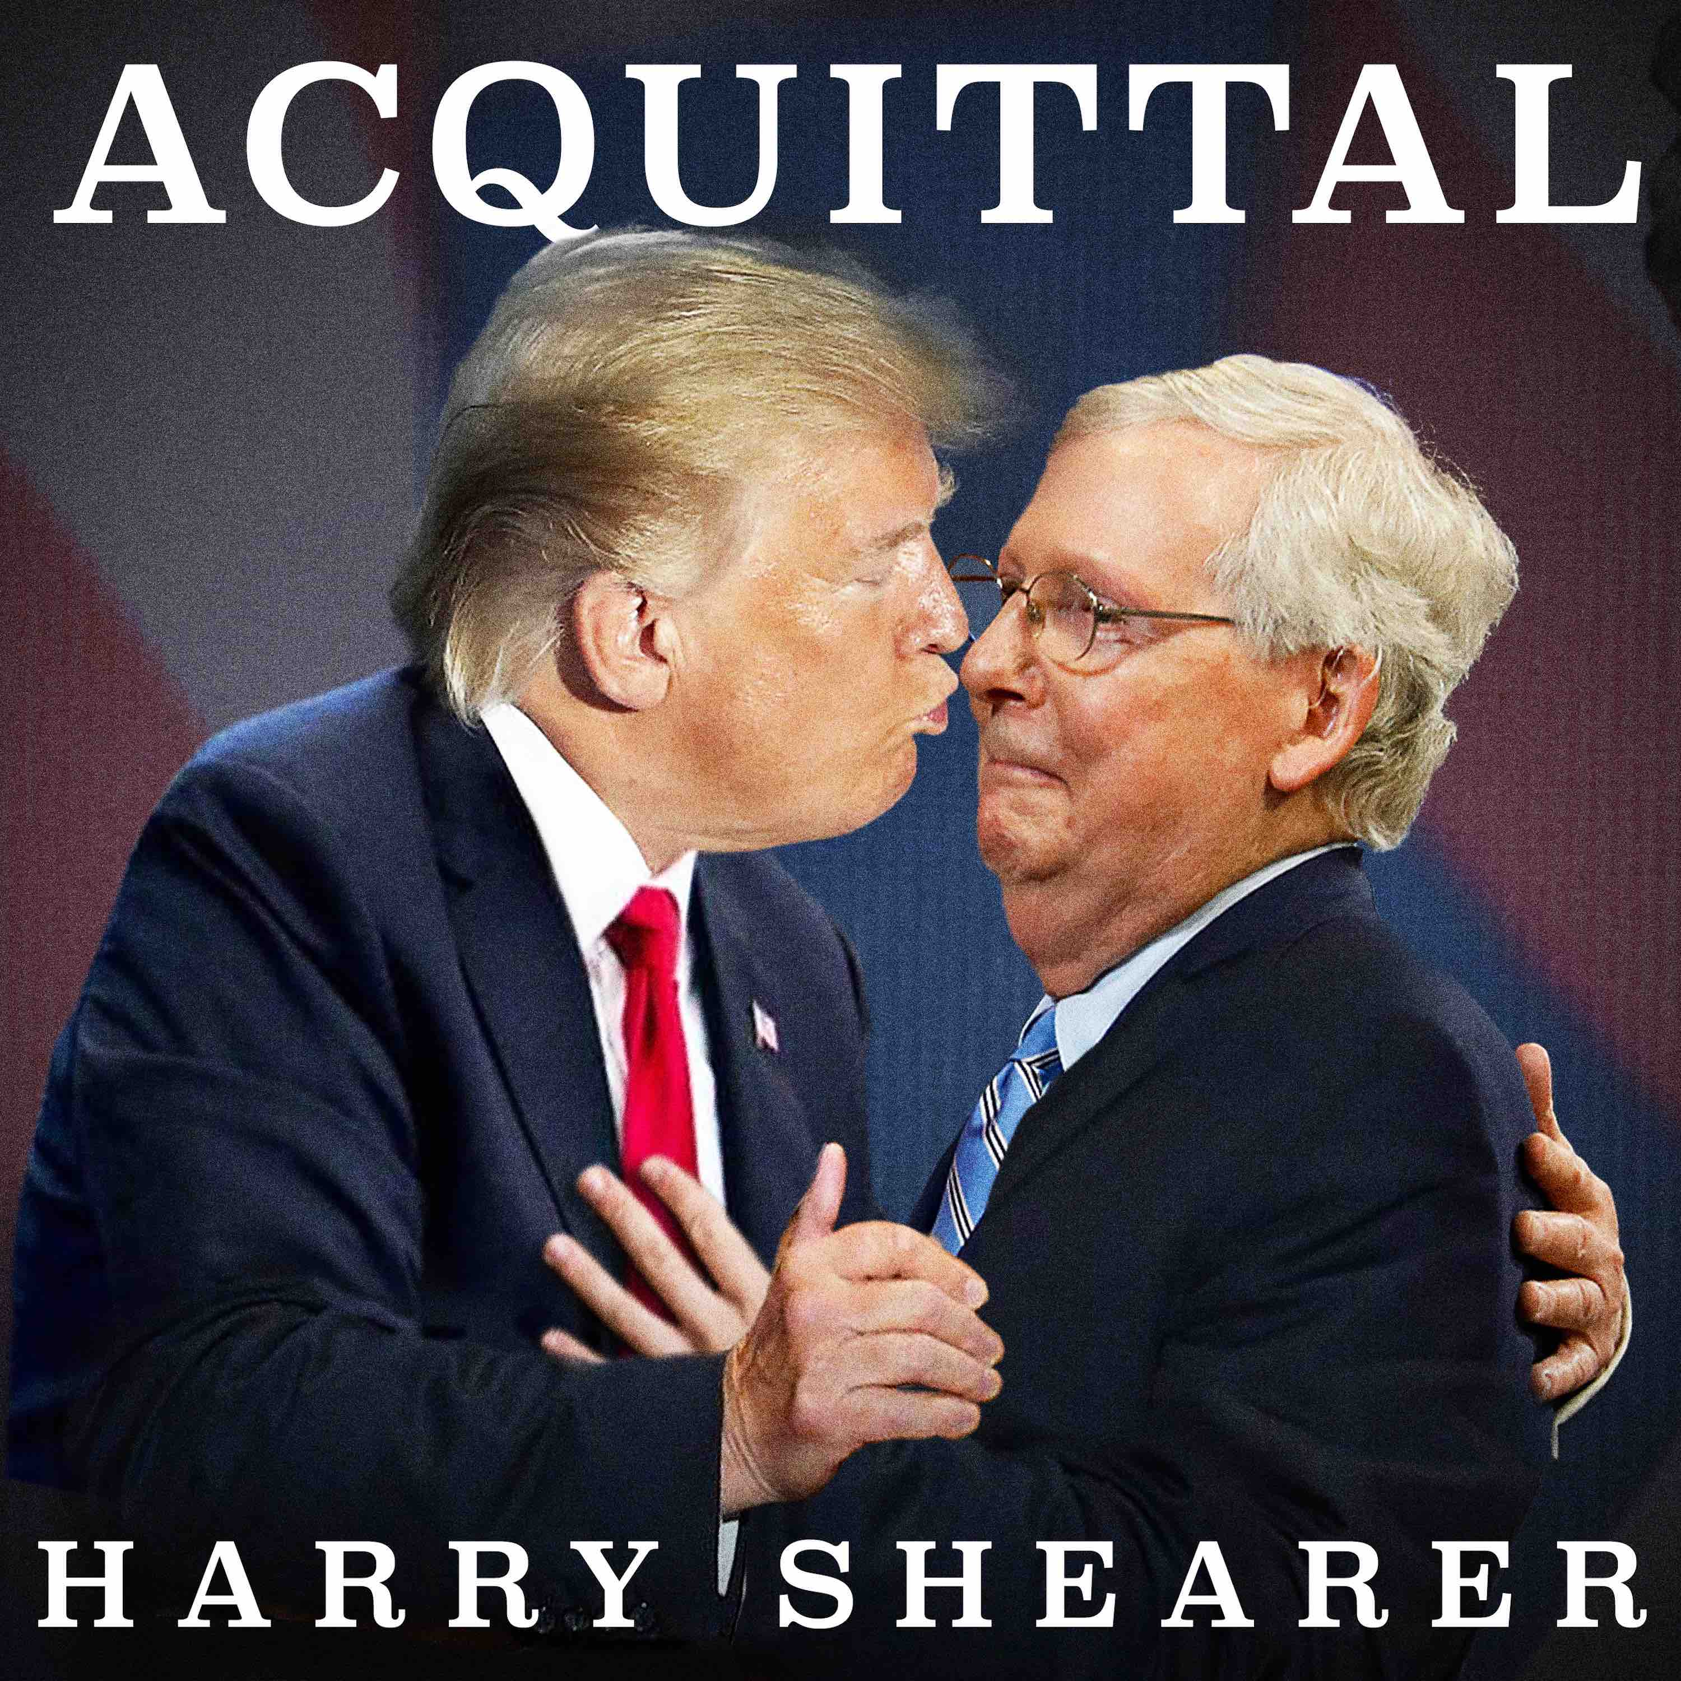
When you cross me I remember
When you serve me I forget
They say I learned a lesson
I haven’t learned one yet
I wake up every morning
So angry and so brittle
But screw all that
It’s payback time
Ever since my Acquittal
#DonaldTrumpSong
ACQUITTAL AVAILABLE TO LISTEN TO - HERE
London September 18, 2020:
As the US election campaign picks up pace, today, Harry Shearer releases the eighth song in his Donald Trump series. ACQUITTAL is the latest addition to the track a week cycle, in which The Simpsons and Spinal Tap star transforms the ups and downs of the current presidency into musical form.
ACQUITTAL is a song of bitterness and vengeance, which has Shearer as Trump wielding the knife as he conducts a purge against both those who testified against him and even some who supported him. In this ‘prog rock revenge anthem’, the president basks in the sheer vitriolic joy on offer when its time to settle scores. As Shearer says -
When you’re impeached, and survive, the natural human impulse is balls-out revenge.
ACQUITTAL features Shearer on lead vocals as Trump, with backing by Sharlotte Gibson and CJ Vanston, Marc Bonilla on guitar, Toss Panos on drums and CJ Vanston on all other instruments. The track is released by Twanky Records.
ACQUITTAL follows the old school R&B anthem to Jared Kushner SON IN LAW (with groundbreaking motion capture video) , the disco/plaintive folk number celebrating Trump’s consistent inconsistency in his approach to the pandemic COVID-180, VERY STABLE GENIUS, a low power power-ballad, in which the Leader of the Free World vaunts his self-proclaimed intellectual prowess combined with his calm and balanced disposition, STORMY DANIELS, a romantic ballad of passion, power and pay off, ALABAMA, a southern rock style tribute to the State that holds such a special place in the Trump ‘heart’, NUMBER ONE SON, Donald Sr’s “electric chop suey” paean to his eldest child Donald Jr and I NEVER KNEW HIM, an eclectic musical mix that demonstrates that The President might not have “one of the greatest memories of all time” as he purges his contact book and airbrushes his history of those who may be an impediment to his ratings.
Harry Shearer has vocally portrayed every US president of his lifetime. Donald Trump is the third he has portrayed physically, having previously played Richard Nixon and Ronald Reagan on screen.
Harry Shearer says of the series of Trump themed song series
"My Donald Trump is almost as eager for continued public attention as the ‘real’ Trump."

Notes for editors
Actor…author…director…comedian…musician…political satirist…multi-media artist…radio personality… record company owner…and one of the best “voices” in the business (just ask THE SIMPSONS), Harry Shearer is a comic personality and modern-day renaissance man.
For the past three decades he has enjoyed enormous success and planted the fruits of his talents in the heads of millions worldwide thanks to his voice work for THE SIMPSONS, where he plays a stable of characters: most notably Mr. Burns, Smithers, and insufferable neighbour Ned Flanders.
Movie audiences will know Shearer best for his collaborations with Christopher Guest and friends. The most famous of these is the granddaddy of all mock-umentaries, THIS IS SPINAL TAP (with Rob Reiner and Michael McKean). The film revealed the concepts of spontaneously combusting drummers and amps that go up to eleven. Spinal Tap - the band have enjoyed worldwide success performing live and in 2007 stole the show at the LIVE EARTH concert at Wembley, London. In 2009 Harry, Christopher and Michael reunited to tour an acoustic version of Spinal Tap songs as themselves in the UNWIGGED AND UNPLUGGED tour (which is available of DVD) and returned as Derek Smalls, Nigel Tufnel and David St. Hubbins to play Glastonbury and Wembley Arena with the volume turned up to eleven. Other Guest collaborations have included, A MIGHTY WIND and FOR YOUR CONSIDERATION. In 2017 Shearer appeared in the film FATHER FIGURE, with Glenn Close, Ed Helms and Owen Wilson.
Shearer’s other film credits include REAL LIFE (co-screenwriter), THE RIGHT STUFF, PORTRAIT OF A WHITE MARRIAGE (director), THE FISHER KING, GODZILLA, THE TRUMAN SHOW, SMALL SOLDIERS and DICK. He has been a regular cast member on SATURDAY NIGHT LIVE twice and, In 2001, wrote and directed his first feature film, TEDDY BEARS' PICNIC, a lightly fictionalized satire of the summer retreat of America's financial and political elite. In 2010, Shearer wrote and directed THE BIG UNEASY, a documentary feature about the investigations into the causes of the 2005 flooding of New Orleans. The film has been selected for numerous film festivals and has won multiple awards including The Golden Eagle Award and The Visionary Award at The DC Independent Film Festival.
In 2013 Shearer created a groundbreaking TV comedy drama series based on real-life recordings from President Nixon’s Oval Office. Written by and starring Shearer as Richard Nixon, NIXON’S THE ONE is made by one of the most respected and prolific UK TV production companies, Hat Trick and was broadcast to great acclaim on Sky Arts.
In 2014 he starred opposite Maureen Lipman in both the West End and on a national UK tour of Oliver Cotton’s acclaimed play DAYTONA.

Harry Shearer is also known for his bitingly satirical songs and impersonations. He was nominated for a Grammy for his CD SONGS POINTED AND POINTLESS. His album SONGS OF THE BUSHMEN (also Grammy nominated) was an incisive musical impeachment of the Bush administration with impersonations in song of the likes of Cheney, Rumsfeld and Colin Powell. In 2009 he released GREED & FEAR – a searing satirical attack on Wall Street in the wake of the world economic meltdown. In the autumn of 2012 he released CAN’T TAKE A HINT, an album of duets featuring the like of Jamie Cullum, Jane Lynch, Fountains of Wayne, Dr John, Rob Brydon and others. Shearer’s musical collaborations with his wife singer/songwriter Judith Owen led to the launch of Courgette Records (a nod to the infamous airport scene from THIS IS SPINAL TAP). Shearer and Owen have recently returned from a critically acclaimed tour of Australia to debut THIS INFERNAL RACKET, a collaborative comedy and music exploration of fame, celebrity, politics, religion and relationships.
In July 2017, at a ceremony in Nashville, Shearer was honoured by National Music Council with American Eagle Award in recognition of his contributions to American and Global Musical Culture as a Writer, Humorist, Musician, Composer, Social Commentator and tireless advocate for the rights and fair treatment of Music Creators in the United States and throughout the World.
In 2015 Shearer wrote and presented the BBC Radio 4 documentary, NEW ORLEANS – THE CRESCENT AND THE SHADOW, which was broadcast to mark the tenth anniversary of the flooding of the city that took place following Hurricane Katrina.
A child of Hollywood, Shearer made guest appearances on a variety of A-list television series while still in his teens. Credits include THE JACK BENNY PROGRAM, GENERAL ELECTRIC THEATRE and ALFRED HITCHCOCK PRESENTS. He was cast and appeared in the pilot of LEAVE IT TO BEAVER as the original Eddie Haskell. His parents, not realising that the show could be picked up were horrified when it was and removed him so he could attend school.
He attended UCLA as a political science major, where he edited and wrote for the school humor magazine. He pursued graduate work at Harvard University and served a political internship in Sacramento before turning to freelance journalism, most notably covering the Watts riots for Newsweek. In 1968, Shearer auditioned for a satirical news team at KRLA-AM called The Credibility Gap. The crew developed a fanatical following, engaging in guerrilla comedy actions like alternative live running commentaries to the annual Rose Parade in Pasadena. The classic Gap lineup including Shearer, future band mate Michael McKean, David Lander, and Richard Beebe began to play local clubs and eventually recorded a number of hilarious - and now scarce - albums, including A GREAT GIFT IDEA, THE BRONZE AGE OF RADIO and FLOATS.
Shearer collaborated with writer Tom Leopold and composer Peter Matz to create the book and lyrics for an original musical film about J.Edgar Hoover titled HERE COMES J EDGAR now in development.
A published novelist (NOT ENOUGH INDIANS), exhibited artist (TELETHESIA at the Fullerton Museum Center and WALL OF SILENCE at MOCA) and celebrated broadcaster (his satirical sandbox LE SHOW, which has recently celebrated its 35th anniversary, is heard weekly on stations around the world), Shearer is a multi-talented entertainer, artist and communicator. His writing has been published in, among other periodicals, the New York Times, Film Comment, and the New York Review of Books.

His good friend and colleague, Derek Smalls, recently released his first solo record since the dissolution of Spinal Tap, SMALLS CHANGE (MEDITATIONS ON AGING). The record features guest performances by the cream of rock artists (Steve Vai, Joe Satriani, Donald Fagen, David Crosby, Rick Wakeman among many others). The live show supporting the record LUKEWARM WATER LIVE received its world premiere in New Orleans 2018, featuring the Louisiana Philharmonic Orchestra and was followed by a special concert 2019 which featured an array of guest talent including, Steve Vai, Steve Lukather, Dweezil Zappa, Paul Shaffer and Tenacious D (Jack Black, Kyle Gass) as well as live link ups with Donald Fagen, Jane Lynch, The Snarky Puppy Horns and The Budapest Symphony Orchestra. In November this year, Derek staged LUKEWARM WATER LIVE at The Wiltern Los Angeles in a live concert that featured Billy Idol, Steve Lukather, Waddy Wachtel, Dweezil Zappa, Paul Shaffer and Judith Owen as well as live link up performances from a star-studded list that included keyboard legend Rick Wakeman.

Twanky Records was co-founded by Harry Shearer and Judith Owen in 2013 as the recording label to release their personal recording projects. The company has since established itself globally with local representation in over twenty countries and distribution via Absolute Label Services alongside Amped/Alliance/AWAL for USA and Canada. Judith Owen’s internationally critically acclaimed albums that have been released under the label comprise Ebb & Flow (2014) - “One of the albums of the year" - The Independent – UK, Somebody’s Child (2016) and redisCOVERed (2018) - both “Top 100 Albums Of The Year” The Sunday Times - UK. Twanky Records - We’re Behind You, Inc is based in California USA

